# 

Adam Sissoko

December 09, 2021

System Design Document

### UML Use Case Diagram

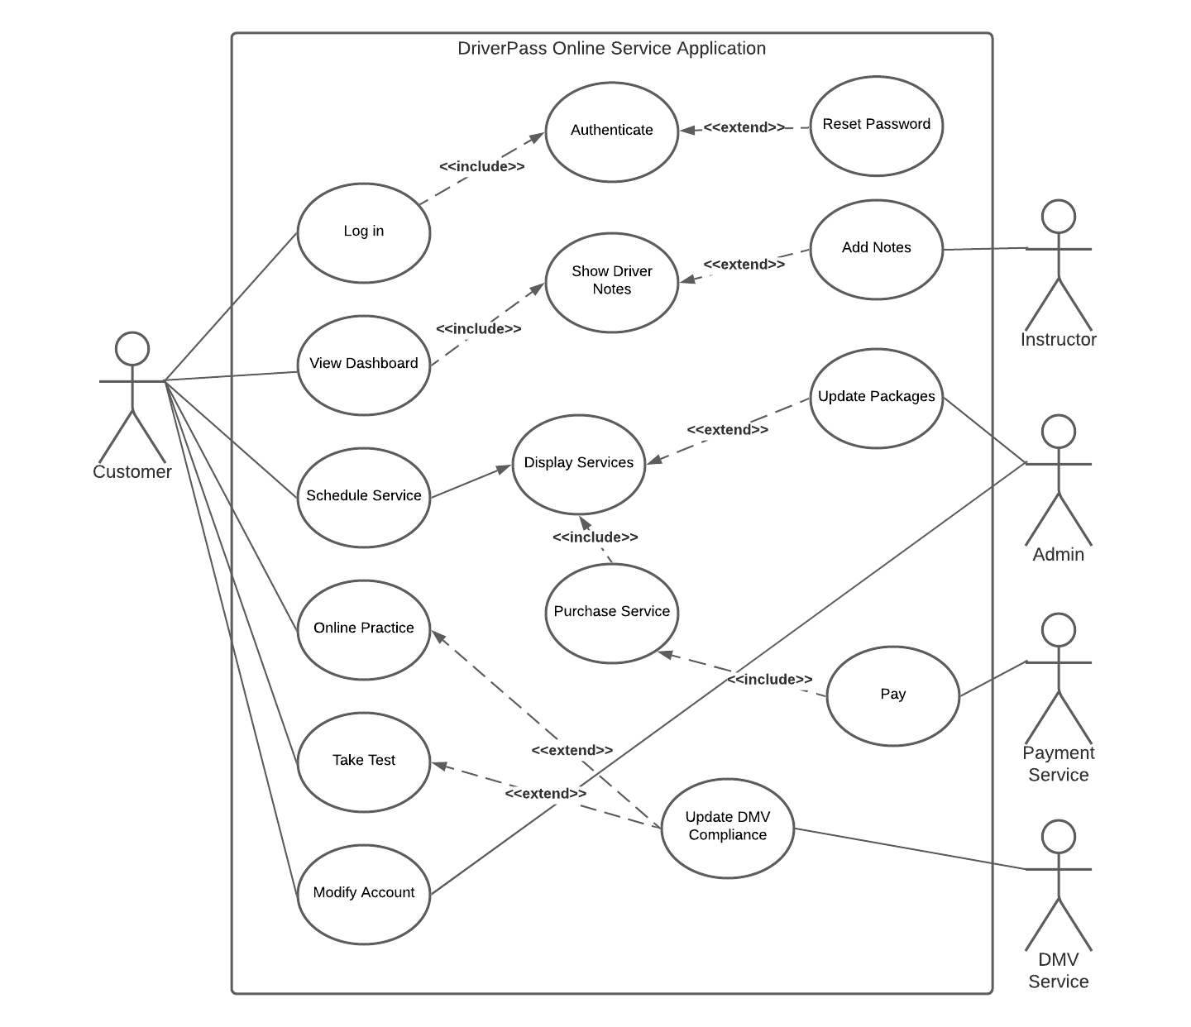

### UML Activity Diagrams

| *Logging In to DriverPass Application* | *Selecting a Service to Purchase* |
| --- | --- |
|  |  |

### UML Sequence Diagram

| *Selecting a Service to Purchase* |
| --- |
|  |

### UML Class Diagram

| *Selecting a Service to Purchase* |
| --- |
|  |

## Technical Requirements

*The DriverPass application will need a hosting service to host the web app, while users access the application via their web browsers. Hosting services should be outsourced to a third party so that DriverPass does not hold the responsibility of server maintenance and other such items. A database of customers and their account information will need to be connected to the application, with an authentication service to authenticate users when they log in. The DriverPass application will also need to access an outside Payment service to accept payments from customers. Likewise, access to the DMV for updating laws and driver requirements will be necessary.*